25.3: a) 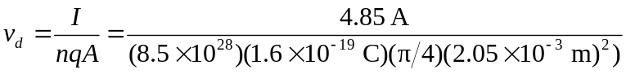
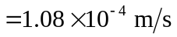
b) If the diameter is now 4.12 mm, the time can be calculated using the formula above or comparing the ratio of the areas, and yields a time of 26542 s =442 min.
c) The drift velocity depends on the diameter of the wire as an inverse square relationship.

